Avocado Sales Forecasting – Eric Oulster

This analysis took a dataset on avocado prices & volumes throughout the continental US and forecasted prospective sales trends for the future.

Aside from Python & Pandas, the package used for this analysis was ‘fbprophet’, an open-source forecasting tool released by facebook.

Because of the substantial size of the dataset, I could afford to split the dataset into two categories: ‘Conventional’ , and ‘Organic’. Because Organic avocados are on average more expensive (and have their own purchasing trends) this split help to provide more insights.

As fbprophet only accepts data presented in a specific format, data preprocessing for this project was about conforming to said format. I removed columns related to avocado purchase volumes, and stuck strictly to price and date.

Sales Forecast for Organic Avocados: y=price per Avocado, ds=date over time

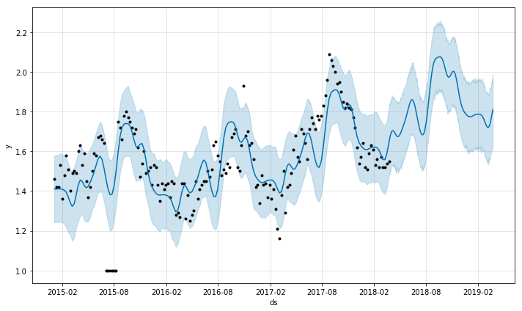

Sales Forecast for Conventional Avocados: y=price per Avocado, ds=date over time

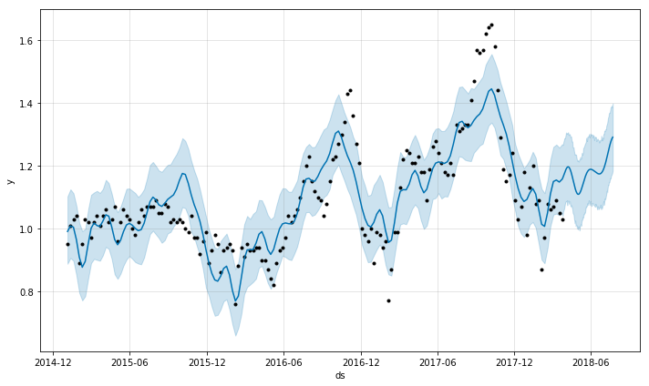

While this dataset lacks up to date information (I am currently conducting this analysis in April of 2019- while the most recent global US data is from February 2018), there are still some observations which can be gleaned from this data.

Avocados follow a ‘seasonality’ in price. Avocados are the least expensive during Spring to Summer. A cursory read suggests that this aligns with the California growing season. Avocados grown in Mexico, however, have consistent production throughout the year.[1]

While both the Organic and Conventional Avocado graphs are normalized to average price, Organic avocados peak in prices are $2.1 usd, and conventional around $1.7 usd.

With the exception of a brief period in August of 2015, Organic Avocados lowest price is approximately $1.2 usd, somewhat of an average price for Conventional Avocados. Conventional Avocados hit a minimum price of around $0.78 usd.

As for this period of August 2015: It is likely that this was an error in recordkeeping of Organic Avocados, and that entries with no price listed were simply given $1.00, a price below market value.

One final observation remains anecdotal, (though imminently practical to my own life): On average, Avocado prices in the United States are far cheaper than those of Toronto, Canada.

A quick search online[2] indicates 2017 Avocado prices in Toronto going as high as $3.45 cad ($2.58 usd). While I lack a dataset to quantify these higher prices, this remains a topic worth investigating.

1. https://www.bonappetit.com/test-kitchen/ingredients/article/why-avocados-always-in-season
2. https://www.cbc.ca/news/business/avocado-prices-canada-1.4097004